PRTF’s first participant of the College Placement Program, Juan Marrero, accepts scholarship to attend Keiser University Florida
Posh Rock Tennis is proud to announce that Juan Marrero, a long-time participant of our College Placement Program, has accepted a tennis scholarship to attend Keiser University Florida.
Juan has been a member of our academy since he began high school four years ago. Francisco (Junior) Gonzalez, his primary coach and mentor, notes: “Juan has continually exemplified the type of work ethic and character we foster and expect from our program participants.”
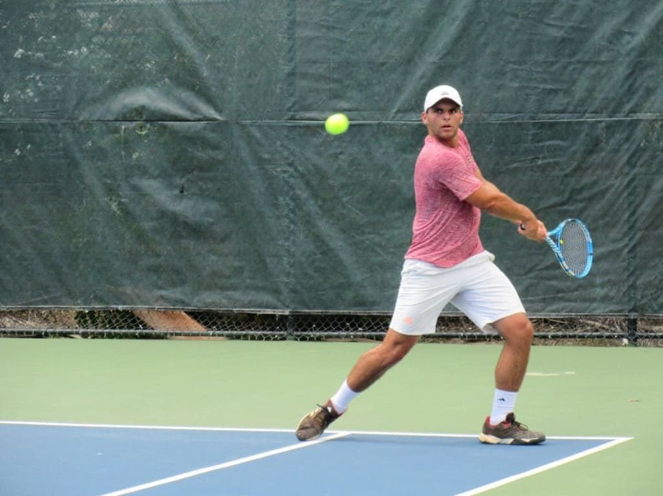
Over the years, Mr. Gonzalez and our other tennis professionals have supplemented his regular training program with countless hours of their time to help guide Juan on his journey.
When Juan came to us in 2015, he was ranked #241 nationally in his class for college tennis recruiting, but now through his hard work Juan has moved up to his current ranking of #113. After accumulating a 17-15 record against ranked opponents and a strong performance at this year’s USTA National Boys u18 Tournament, Juan received a flurry of Division I interest.
After much deliberation with his family, Juan decided to stay home, in Florida. Juan will begin classes this fall and become an integral part of the team this season.

